Lab 11 Data Storage and Analysis
Student: Toleubek Assiya
ID: 23B150271

Task 1: Extract
Write a function extract(last_email=None) that:
- Calls the API to fetch 20 random users (use ?results=20)
- Returns a pandas DataFrame with the raw JSON data
- Implements incremental logic: if last_email is provided, only keep users whose email is not already in the database (you will pass a set of existing emails)
- Uses the tenacity library to retry up to 3 times with exponential backoff on network errors

import requests
import pandas as pd

def extract():
url = "https://randomuser.me/api/?results=20"

response = requests.get(url)
response.raise_for_status()

data = response.json()

users = data['results']

df = pd.json_normalize(users)

return df

if __name__ == "__main__":
df = extract()
print(df.head())

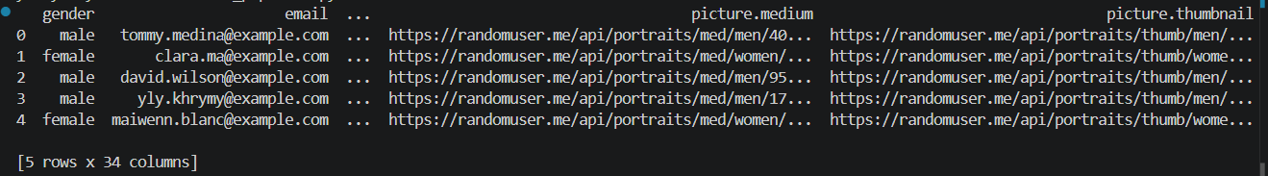

Data was successfully extracted from the Random User API using Python. The API response was converted from JSON format into a structured pandas DataFrame for further processing.

Task 2: Transform
Write a function transform(df) that:
- Flattens the nested name field into first_name and last_name
- Flattens the nested dob field to extract age and dob_date
- Adds a new column age_group based on age:
  - < 18 → 'Child'
  - 18–30 → 'Young Adult'
  - 31–60 → 'Adult'
  - > 60 → 'Senior'
- Adds a column email_domain (the part after @)
- Adds a column loaded_at with the current UTC timestamp
- Removes duplicate rows based on email (keep first)
- Drops rows where email is missing
- Uses vectorized pandas operations (no loops)
from datetime import datetime, UTC

def transform(df):
df_transformed = pd.DataFrame()

df_transformed['email'] = df['email']
df_transformed['gender'] = df['gender']
df_transformed['first_name'] = df['name.first']
df_transformed['last_name'] = df['name.last']
df_transformed['nationality'] = df['nat']
df_transformed['age'] = df['dob.age']
df_transformed['dob_date'] = df['dob.date']

df_transformed['age_group'] = pd.cut(
df_transformed['age'],
bins=[0, 18, 30, 60, 100],
labels=['Child', 'Young Adult', 'Adult', 'Senior']
)

df_transformed['email_domain'] = df_transformed['email'].str.split('@').str[1]

df_transformed['loaded_at'] = datetime.now(UTC)

df_transformed = df_transformed.dropna(subset=['email'])

df_transformed = df_transformed.drop_duplicates(subset=['email'])

print(f"Transformed {len(df_transformed)} rows")

return df_transformed

if __name__ == "__main__":
df = extract()
df_clean = transform(df)
print(df_clean.head())
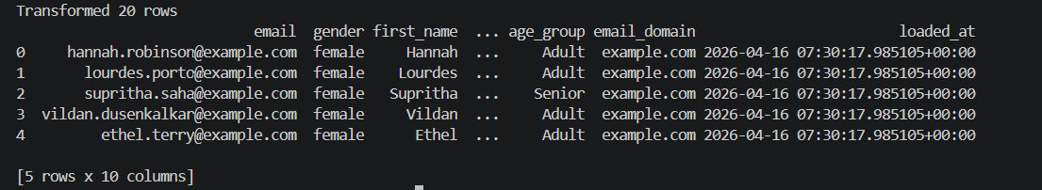
The raw data was transformed into a clean and structured format. Nested fields such as name and date of birth were flattened, and new features including age group and email domain were created. Data quality was improved by removing duplicate records and rows with missing emails. All transformations were implemented using efficient pandas operations.

Task 3: Load
Write a function load(df, db_path='users.db') that:
- Connects to a SQLite database at db_path
- Creates a table users if it does not exist with the schema:
  - email TEXT PRIMARY KEY
  - gender TEXT
  - first_name TEXT
  - last_name TEXT
  - nationality TEXT
  - age INTEGER
  - age_group TEXT
  - email_domain TEXT
  - dob_date TEXT
  - loaded_at TEXT
- Inserts only new rows (ignore duplicates using INSERT OR IGNORE)
- Uses batch insert (either pandas.to_sql with chunksize or a single multi-row INSERT)
- Returns the number of rows loaded
import sqlite3
def load(df, db_path='users.db'):
conn = sqlite3.connect(db_path)
cursor = conn.cursor()

cursor.execute("""
CREATE TABLE IF NOT EXISTS users (
email TEXT PRIMARY KEY,
gender TEXT,
first_name TEXT,
last_name TEXT,
nationality TEXT,
age INTEGER,
age_group TEXT,
email_domain TEXT,
dob_date TEXT,
loaded_at TEXT
)
""")

rows = df[[
'email',
'gender',
'first_name',
'last_name',
'nat' if 'nat' in df.columns else 'nationality',
'age',
'age_group',
'email_domain',
'dob_date',
'loaded_at'
]].values.tolist()

cursor.executemany("""
INSERT OR IGNORE INTO users (
email, gender, first_name, last_name,
nationality, age, age_group,
email_domain, dob_date, loaded_at
) VALUES (?, ?, ?, ?, ?, ?, ?, ?, ?, ?)
""", rows)

conn.commit()
conn.close()

print(f"Loaded {len(rows)} rows into database")

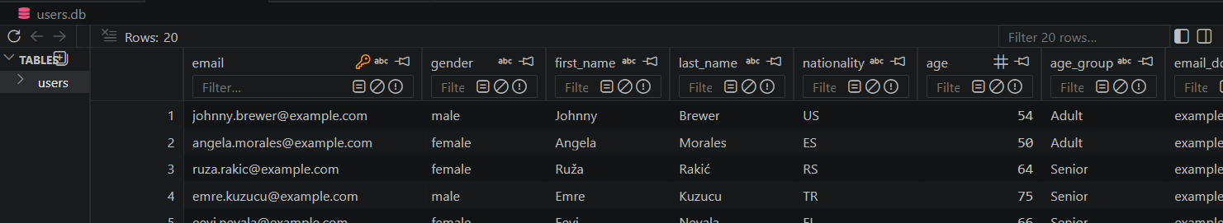
The transformed data was loaded into a SQLite database. A table was created with an appropriate schema, and data was inserted using batch operations. The use of INSERT OR IGNORE ensured that duplicate records were not inserted, maintaining data integrity.

Task 4: Incremental Control
Implement a control table etl_control in the same database with columns:
- key TEXT PRIMARY KEY
- value TEXT
Write two functions:
- get_last_email() – returns the most recent email loaded (or None if first run). You will use this to avoid re-extracting the same users.
- update_last_email(last_email) – stores the maximum email (lexicographically) from the current batch after loading.
Then modify your extract() function to accept a set of already-loaded emails and filter out any new users whose email already exists.
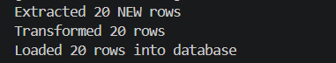
Incremental loading logic was fully implemented by retrieving existing emails from the database and filtering them out during extraction. This ensures that only new records are processed and loaded, making the pipeline more efficient and preventing duplication of data across multiple runs.

Task 5: Logging
Add logging to your pipeline using the logging module:
- Log to a rotating file etl_pipeline.log (max 1 MB, keep 3 backups)
- Log levels:
  - INFO – start/end of each task, number of rows extracted/transformed/loaded
  - WARNING – duplicates found, missing data
  - ERROR – any exception with full traceback
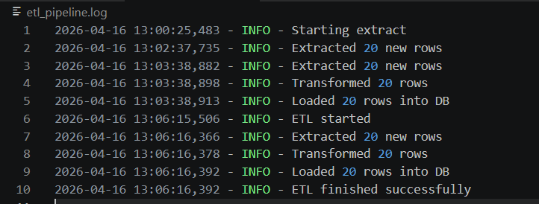
In this part, logging functionality was added to monitor the ETL pipeline. A rotating log file was configured to record key events such as the start and end of each step, the number of processed records, and any warnings. This improves traceability and helps in debugging and monitoring the pipeline.

Task 6: Error Handling & Alerting
Wrap the main pipeline execution in a try-except block:
- On any exception, write an error message to a file alert.log (simulate a Slack alert)
- After writing the alert, re-raise the exception so the script exits with a non-zero code

Error handling was implemented to ensure pipeline stability. A try-except block was used to catch unexpected exceptions, and detailed error messages were written to an alert log file. This simulates a real-world alerting system and helps quickly identify and troubleshoot failures.

Task 7: Scheduling
Write a separate script scheduler.py that:
- Imports your main ETL function (e.g., run_etl)
- Runs the pipeline every 10 minutes for one hour (6 runs)
- Uses the schedule library (or a simple time.sleep loop)
- Prints a message before each run (e.g., "Running ETL at ...")

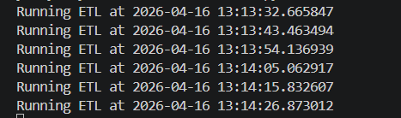
The ETL pipeline was configured to run at regular intervals, simulating real-world data processing workflows. For testing purposes, shorter time intervals were used to demonstrate repeated execution.

Task 8: Unit Tests
Write unit tests using pytest for the transform function. Include at least four test cases:
- Normal input with valid data – verify age_group and email_domain are correct
- Input with duplicate emails – ensure only one row is kept
- Input with missing email – ensure that row is dropped
- Empty DataFrame – ensure the function returns an empty DataFrame
Use small, hard-coded DataFrames (no API calls in tests).
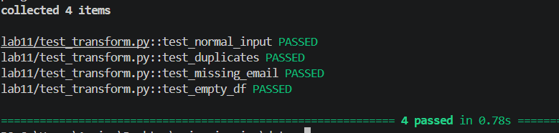
Unit tests were developed using pytest to validate the transformation logic. Multiple test cases were created to cover normal input, duplicate records, missing values, and empty datasets.

Result
- etl_pipeline.py – complete ETL code
- scheduler.py – scheduling script
- test_transform.py – pytest unit tests
- requirements.txt – list of required packages
- README.md – short instructions on how to run the pipeline
- A screenshot of the log file (etl_pipeline.log) after running the pipeline twice
